SPRINT-3

|  |  |
| --- | --- |
| **Date** | 18 November 2022 |
| **Team ID** | PNT2022TMID29786 |
| **Project Name** | Smart Fashion Recommender Application |

Sendgrid connection:

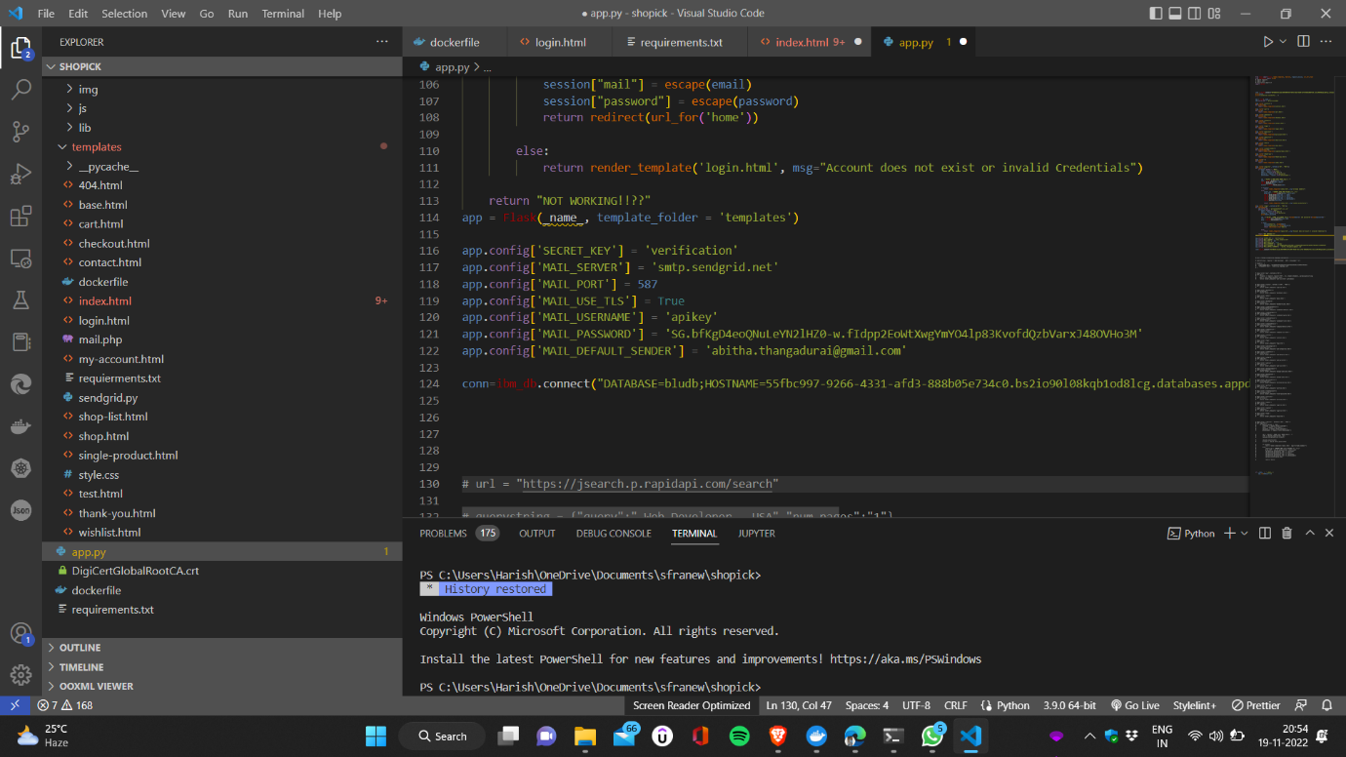

import os

from sendgrid import SendGridAPIClient from sendgrid.helpers.mail import Mail from ..lib import exception

def sendemail():

message = Mail( from_email='from_email@example.com', to_emails='to@example.com', subject='ORDER CONFIRMATION',

html_content='<strong>Your order placed</strong>') try:

sg = SendGridAPIClient(os.environ.get('SENDGRID_API_KEY'))

response = sg.send(message) print(response.status_code) print(response.body) print(response.headers)

except Exception as e:

return exception.handle_exception(e)

Docker setup:

